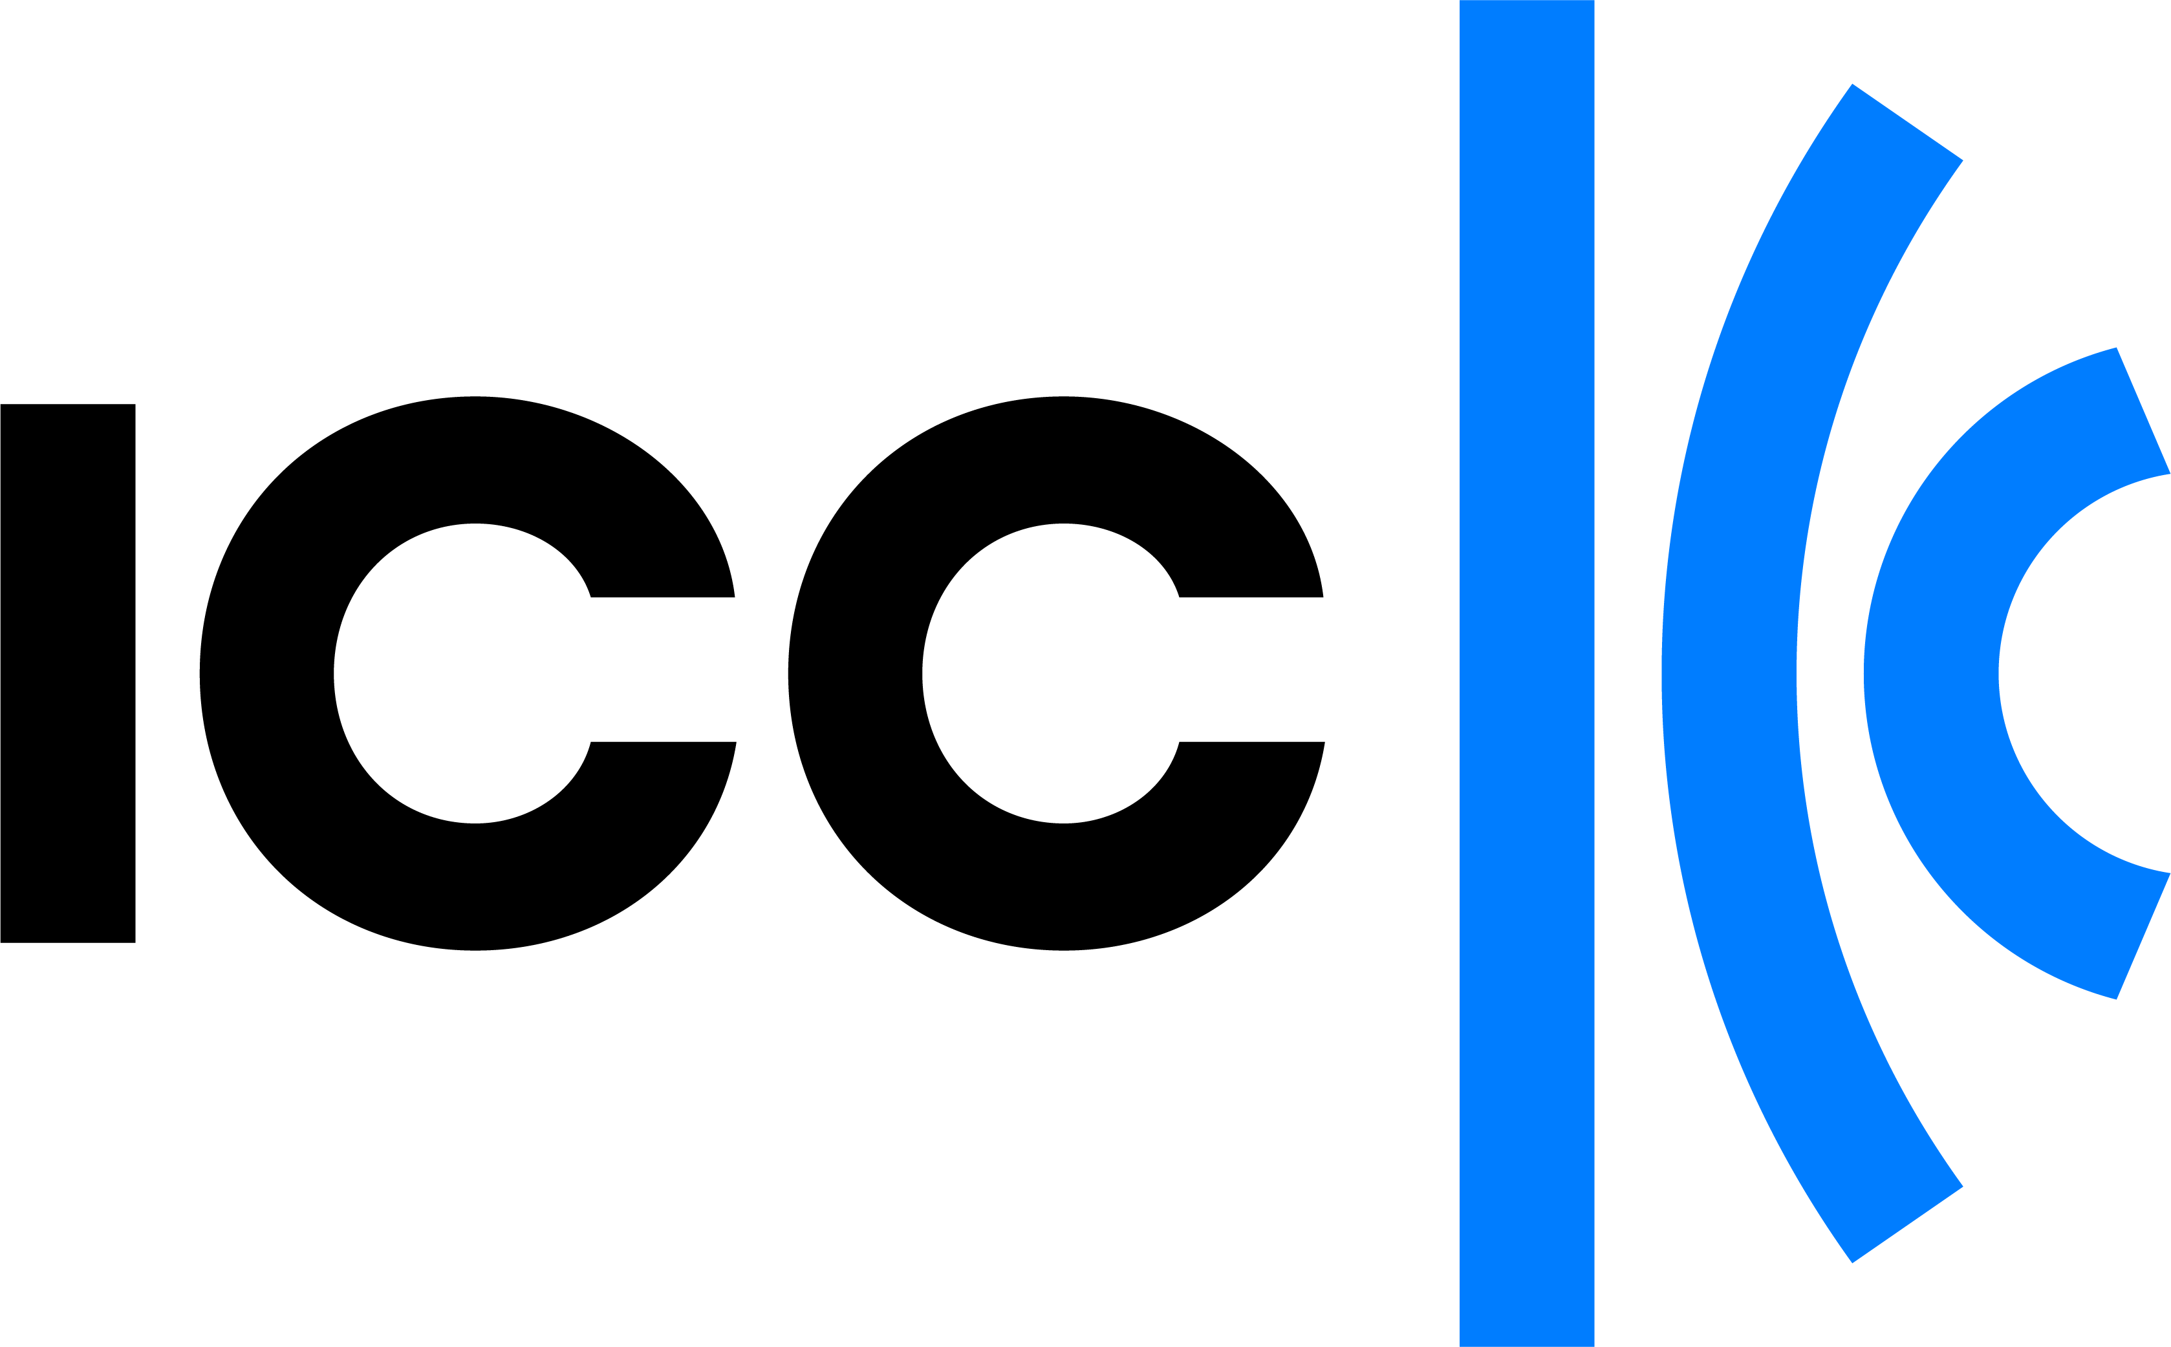

Global Policy Commissions

Workplan 2026

[Draft 24 October 2025]

How we work
As the institutional representative of over 45 million businesses in more than 170 countries, we are uniquely positioned to leverage private-sector expertise and insights to deliver practical solutions to interconnected challenges.
We act as the primary voice of the real economy in a range of intergovernmental organisations – from the United Nations to the World Trade Organization – championing the needs of local business in global decision making.
Our business-centric but purpose-led approach to external engagement provides us with the credibility and integrity needed to build trusted and influential relationships with policymakers across the world.
The convening power of our global network enables us to set rules and standards that facilitate over $17 trillion dollars in trade each year – as well as to provide tailored products and services that directly address the real challenges faced by businesses operating internationally.
We also provide the world’s premier private global dispute resolution services, leveraging ICC’s unique independence, integrity and expertise.

Our policy commissions
Our 11 global policy commissions bring together thousands of leading professionals across different technical disciplines – providing an unparalleled source of global business expertise from which we develop high-impact content and initiatives.
While the commissions themselves serve as thematically focused forums, we also deploy cross-cutting working groups to blend expertise from different specialist areas – allowing us to create outputs with a genuinely holistic take on real-world challenges.
Our commissions draw on the expertise and reach of our global network and deliver value in four principal ways:
- Keeping members updated on key policy developments and enabling peer-exchange on emerging trends
- Developing common industry positions on major public policy issues
- Delivering technical input to shape key intergovernmental processes
- Establishing common rules and self-regulatory standards for cross-border commerce.
To maximise the impact of the substantive outputs from our commissions, we leverage ICC’s unique access into major multilateral organisations – while working hand-in-hand with our network of national committees with direct links into national capitals and local business communities.

Special initiatives and partnerships
In addition to our policy commissions, several special initiatives and partnerships provide specialist services to business and support the implementation of critical policy reforms at country level.

Our global strategy
Recognising the severe challenges faced by business as a result of uncertain economic and geopolitical conditions, we are committed to ensuring that ICC’s policy work informs effective decision-making by governments – for a policy and regulatory framework that supports global trade and a level playing field – while providing business with the tools they need to facilitate cross-border business and drive sustainable development.
In this context, our global operations are guided by a strategic framework encompassing five defining themes for the future of international business:
- Enabling global trade
- Promoting access to justice, integrity and respect for the rule of law
- Accelerating sustainability and climate action
- Shaping an open, trusted and interoperable digital economy
- Strengthening multilateral cooperation.
This strategy is deployed and coordinated through our global network, allowing ICC to bridge between global and local action, and between different regions and countries.

Priority commission projects for 2026
In this context, our headline work programme for 2026 responds to each of these strategic themes. We place a strong focus on projects where ICC can provide a unique value proposition to our corporate members, by working across policy areas and through close collaboration between different parts of our global network.
- Rules, standards and guidance | - Policy advocacy

Banking (trade, supply chain and export finance)
- Upgrade and grow the ICC Trade Register to establish this data pool as the definitive source of market intelligence for trade finance products for banks, investors and regulators.
- Issue new financial crime and risk policy guidance for trade finance transactions.
- Issue guidance on the application of ICC banking rules in the form of opinions and technical advisory briefings.
- Assess the need for revisions of, or updates to, other key ICC rules and guidance products.
- Support the adoption of digital processes under ICC trade finance rules – including through the development and implementation of standardised Application Programming Interfaces (API).
- Secure proportionate capital treatment of trade finance assets in the context of key legislative initiatives while establishing trust-based relationships with banking regulators.
- Monitor and develop feedback on UNCITRAL's ongoing work regarding the digitalisation of negotiable cargo documents.

Business integrity (anti-corruption and corporate social responsibility)
- Promote widespread usage of the revised ICC Rules on Combatting Corruption – including through the development of an updated ICC Anti-Corruption Clause.
- Make the business case that integrity is more urgent than ever in uncertain regulatory and geopolitical times.
- Initiate discussions and examination of AI use cases that foster integrity.
- Bolster coordination and best practice sharing between mirror Business Integrity commissions within ICC’s network.
- Lead business engagement in key international processes for integrity, anti-corruption and responsible business conduct norms, including at the UN , and the OECD.
- Monitor key processes relating to business and human rights, and ESG regulations

Commercial law and practice
- Develop and pilot practical tools to facilitate the effective use of the ICC Incoterms® rules by businesses throughout the world.
- Begin work on the revision of the Incoterms rules, laying the groundwork for Incoterms 2030.
- Update and expand ICC’s suite of model contracts and clauses to meet new business needs.
- Monitor the evolution of new technologies to identify opportunities for facilitating the effective use of ICC tools and standards in an increasingly digitalised trading ecosystem.
- Collaborate with private law intergovernmental organisations to develop model contract language and practices.
- Champion the modernisation of legal frameworks to enable digitalisation of cross-border trade processes.

Competition
- Provide guidance to help companies navigate increasingly complex policy approaches to foreign subsidies.
- Deploy and promote with antitrust regulators updated tools to support companies in building robust antitrust compliance systems.
- Shape a step-change in antitrust policy to enable essential industry collaboration for meeting global climate and sustainability goals – targeting key jurisdictions in Asia, North America and Latin America.
- Encourage increased harmonisation of national merger control regimes to provide greater certainty and predictability for business operating internationally.
- Initiate discussions with competition authorities to examine anti-competitive practices. arising from various national laws on digitalisation and artificial intelligence.

Customs and trade facilitation
- Deliver business insights into key World Customs Organization workstreams – including on valuation (covering transfer pricing) and product classifications.
- Address challenges on rules of origin driving practical solutions, promoting convergence, and offering business-driven recommendations
- Deliver thought leadership on evolving challenges for national customs agencies in areas such as climate border measures, circular economy, e-commerce, and digitalisation.
- Advocate for improved “trusted trader” programmes, including through fostering the participation of MSMEs.
- Provide a platform to identify – and respond to – key in-country trade facilitation challenges using the full reach of ICC’s national committee network.

Digital economy
- Advoca te for reducing regulatory fragmentation in digital policies to create an enabling environment for global trade.
- Advocate for stronger cybersecurity, enhanced international cooperation to combat cybercrime, and secure cross-border data flows to help build a trusted and secure digital economy.
- Inform the development of global policy frameworks to enable “data free flow with trust”, focusing on the intersection between data and trade policies.
- Advocate for policy and governance frameworks that promote and enable meaningful and inclusive access to existing and emerging technologies, in particular artificial intelligence.
- Lead business engagement in intergovernmental discussions on the future governance of the Internet, together with the ICC BASIS initiative.

Environment and energy
- Channel business expertise into critical-path UN Framework Convention for Climate Change negotiations ahead of COP31.
- Lead business engagement to support the development of functioning, high-integrity, cross-border carbon markets, including under Article 6 of the Paris Agreement and advocate for the harmonisation and effective design of carbon border adjustment mechanisms.
- Continue to advocate for concrete pathways to unlock private climate finance in emerging and developing economies, including through prudential regulatory clarification and reform.
- Lead business engagement in key international environmental processes, including advancing efforts towards the conclusion of an effective international treaty to curb plastics pollution.
- Deliver business insights on evolving issues at the intersection of sustainability and key policy developments, including on areas such as artificial intelligence, green infrastructure and circular supply chains.
- Expand endorsement and adoption of the ICC Principles for Sustainable Trade Finance, as a foundation for ongoing work on sustainable trade.
- Develop and implement a roadmap for a centralised global data hub on energy transition mineral flows and impacts to enhance transparency and inform decision-making.
- Facilitate exchanges on implementation of the Global Biodiversity Framework in the lead up to Convention on Biological Diversity COP17.
- Support ICC initiatives focused on advancing SME sustainability and climate action.

Intellectual property
- Lead business engagement in UN biodiversity negotiations on benefit sharing frameworks at the interface between research, innovation and biodiversity preservation.
- Collaborate with leading programmes at the World Intellectual Property Organisation (WIPO) to ensure an enabling environment for business innovation.
- Support the roll-out of tools to help small businesses better leverage their IP assets, in collaboration with WIPO.
- Update the flagship ICC IP Roadmap in response to new policy developments and industry trends.

Marketing and advertising
- Run a comprehensive global awareness campaign to promote the 11th edition of the ICC Advertising and Marketing Communications Code, including using different language editions to reach new audiences .
- Leverage the campaign to reach geographies without an existing self-regulatory body to ensure broader adoption and endorsement of the new ICC Code.
- Promote updated ICC frameworks on environmental claims, food and beverages, alcohol, and new guidance on artificial intelligence to support global alignment and practical implementation.
- Advance new global guidance on responsible advertising practices for vulnerable audiences, such as children and teens, especially regarding deceptive advertising practices and scams.
- Demonstrate the continued relevance of advertising self-regulation on issues of growing interest to policymakers and consumers – such as influencer marketing, green claims and the use of new technologies.
- Monitor key international developments and standard-setting processes relevant to advertising and marketing to safeguard the integrity of self-regulatory frameworks.

Taxation
- Provide business insights to shape workable international tax reforms under the new UN Tax Framework Convention Process and the OECD inclusive framework, emphasising the need for tax certainty and international coordination.
- Lead business engagement in key regional forums which have the potential to shape international tax norms – including the Platform for Taxation in Latin America and the Caribbean, and the EU Commission Platform for Tax Good Governance.
- Advocate for the implementation of robust tax dispute prevention and resolution mechanisms.
- Lead international debate on the appropriate tax treatment of cross-border teleworkers in a post-pandemic world.
- Support business in navigating the relationship between tax, sustainability policy and ESG reporting – including the development of a new report on the role of taxation in the implementation of the UN Sustainable Development Goals.

Trade and investment
- Identify, shape and drive business proposals for revitalizing the global trading system, ensuring private sector priorities, perspectives and solutions are embedded in multilateral trade discussions
- Lead business advocacy on priority trade issues in preparation for the World Trade Organisation’s (WTO) 14th Ministerial Conference, including WTO reform and the WTO Moratorium on Customs Duties on Electronic Transmissions
- Deliver business insights to shape high-standard outcomes on digital trade rulemaking, including on data flows.
- Lead the global debate on trade policy reforms and harmonisation of rules and standards to meet global sustainability goals, including in the areas of carbon border adjustments and circular economy, and through the development of Ecoterms.
- Champion open and transparent cross-border investment – backed by good regulatory practices, with a focus on financing for development.

External engagement opportunities
ICC is committed to providing high quality engagement opportunities for members to participate in and contribute expert insights to critical intergovernmental negotiations, both directly and indirectly. Complementing the global policy commissions, ICC leverages its Permanent Observer status to the UN General Assembly to accredit delegations of business leaders to intergovernmental conferences held by the UN and its associated organisations.
In 2026, engagements will include a programme of events on the margins of the opening of the UN General Assembly in New York and the WTO 14th Ministerial Conference in Cameroon, the ICC pavilion at the UN Climate Change Conference (COP31), as well as opportunities to engage in other multilateral processes under the UN and other intergovernmental bodies. These opportunities are developed based on feedback from ICC national committees and commission members – ensuring that resources are allocated for maximum impact and return on investment.

Special initiatives and partnerships
We maintain several special initiatives and partnerships to provide specialist services to business and support the implementation of critical policy reforms at country level – leveraging, where relevant, the work of the global policy commissions. These include:
ICC Digital Standards Initiative (no changes)
The ICC Digital Standards Initiative (DSI) leads global efforts to eliminate paper-based processes in trade by accelerating the adoption of interoperable standards and enabling legal frameworks. DSI 2.0 builds on these efforts to scale implementation worldwide, empowering businesses of all sizes to fully embrace and benefit from trade digitalisation.
- Develop and disseminate practical adoption guides for data and technical standards enabling businesses to create, manage and exchange interoperable supply chain data in accordance with the Key Trade Documents and Data Elements (KTDDE) framework.
- Develop certification frameworks for digital trust at scale to enable systems and supply chain partners to develop and demonstrate their readiness for digital trade.
- Expand the reach of existing capacity-building resources to boost digital trade capabilities and readiness across sectors and regions.
- Provide tailored legal and technical assistance to governments and business-led advocacy efforts to promote the adoption of modern legal frameworks, such as the Model Law on Electronic Transferable Records (MLETR), working closely with multilateral development banks to advance legal reforms in both developed and developing countries.
Global Alliance for Trade Facilitation

The Global Alliance for Trade Facilitation is a unique donor-funded initiative, co-led by ICC, and aimed at improving trade processes in developing and least developed countries through local, public-private partnerships. Since 2015, the Alliance has designed and implemented sustainable trade facilitation solutions in 30+ developing countries across the globe to streamline trade and strengthen supply chain resiliency.
- Continue to scale up activities based on funding from donors such as Sweden and the European Union in several countries, including Ukraine, Cameroon, and Egypt.
- Attract additional private sector partners that can join the Alliance and provide in-kind contribution to projects.
- Implement and step up the joint ADEPT-initiative together with UNICEF to improve access to essential humanitarian aid across ten countries, including Nepal, Madagascar, and Bangladesh.

ICC Business Action to Support the Information Society
ICC BASIS promotes global business priorities on a range of Internet governance and digital policy issues in forums established by the United Nations World Summit on the Information Society (WSIS), and works to preserve the multistakeholder approach to these issues.
- Represent global business priorities in the outcomes and follow up of the 20-year review of the WSIS that set the UN’s approach to digital policy;
- Strengthen business participation in the Internet Governance Forum as the prime venue for multistakeholder debates on digital policy.
- Ensure global business experience and expertise is at the base of implementing the Global Digital Compact and its outcome processes.

SME action
A holistic portfolio of engagement focused on the needs of small business – encompassing ICC’s SME Champions Network, private sector expertise and the development of practical guidance and tools to enable access to finance, effective digitalisation and ambitious climate action.
- Deploy and further enrich ICC One Click, a multilingual portal showcasing ICC tools and services (model contracts, Incoterms® rules, ATA Carnets and dispute resolution) and services by ICC institutional partners, such as the Global Trade Helpdesk, to help SMEs navigate complex regulations and guide them through their cross-border trade journey .

About the International Chamber of Commerce
The International Chamber of Commerce (ICC) is the institutional representative of more than
45 million companies in over 170 countries. ICC’s core mission is to make business work for everyone, every day, everywhere. Through a unique mix of advocacy, solutions and standard setting, we promote international trade, responsible business conduct and a global approach
to regulation, in addition to providing market-leading dispute resolution services. Our members include many of the world’s leading companies, SMEs, business associations and local chambers of commerce.
33-43 avenue du Président Wilson, 75116 Paris, France
T +33 (0)1 49 53 28 28 E icc@iccwbo.org
www.iccwbo.org @iccwbo

In conjunction with the ICC Digital Standards Initiative
In conjunction with the ICC Digital Standards Initiative
In conjunction with the ICC Global Trade and Investment Commission
In conjunction with the ICC Global Taxation Commission
Including in conjunction with the ICC Digital Economy Commission
In conjunction with the ICC Global Banking Commission
In conjunction with the ICC Environment and Energy Commission.
In conjunction with the ICC Global Environment & Energy Commission

