12/21/2023

ICC and EY team

[company name]

**DRAFT FOR COMMENT - NOT FOR CIRCULATION OR DISTRIBUTION**

Contents

1. Executive Summary 1

2. Introduction 2

3. Background on the circular economy 2

4. Barriers to circular economy 4

4.1. Policy and regulatory 5

4.2. Technological 7

4.3. Infrastructure 8

4.4. Financial 8

4.5. Organisational 9

4.6. Social 10

5. Measures to support the transition to a circular economy 12

5.1. Policy and regulatory opportunities 12

5.2. Technological opportunities 13

5.3. Infrastructure opportunities 13

5.4. Financial opportunities 15

5.5. Social and organisational opportunities 16

6. Key recommendations 16

7. Annex 18

7.1. Research methodology 18

7.2. References 19

# Executive Summary

Placeholder – to be added.

# Introduction

Circular economy is an important tool to drive sustainability at scale. It rethinks the “take-make-waste" linear economy and moves towards an economic model that aims to maximise resource efficiency, reduce waste, and minimise environmental impact by promoting continuous use, reuse, and recycling of materials and products. Although its economic, environmental, and social benefits are numerous, the transition to circular business models has been slow and not at the expected scale. Currently, the world is estimated to be only 7.2% circular – a decrease from 9.1% over the past five years, due primarily to increasing virgin material extraction.[1]

In the case of consumer-related goods, the transition to a circular economy depends on the creation of a market shift and demand for secondary sourced materials. But this shift is being impeded by many barriers ranging from regulatory to consumer behaviour. This report aims to examine the barriers that hinder the meaningful adoption of circular economy approaches for such goods, while highlighting measures that would enable the adopting and scaling of circular economy. The research methodology employed a combination of literature review, stakeholder interviews, and surveys of industries, including manufacturing, renewables, information technology, chemicals and life sciences, and textiles. *(Detailed information in Annex)*

# Background on the circular economy

There is currently no universal definition for the circular economy. However, in this report, circular economy is understood as an economic model that aims to maximise the economic value of materials. This objective is achieved through optimising resource efficiency by reducing waste, materials, and products. At the same time, the model minimises environmental impact by extending the lifespan of materials and products through different “r-strategies”, including reuse, repair, refurbishment, remanufacturing, recycling, and reduction of materials and products. It is a systemic approach that transforms the way economies currently operate by decoupling economic activity from the consumption of finite resources.

Unlike the traditional linear economy, which follows a "take-make-waste" pattern, the circular economy seeks to create a closed-loop system where materials and products are kept in circulation at their highest value for as long as possible. The circular model creates value by simultaneously enabling economic growth and positive ecological impacts.​ Ultimately, the circular economy is a transformative process which reimagines and redesigns social and business interactions.

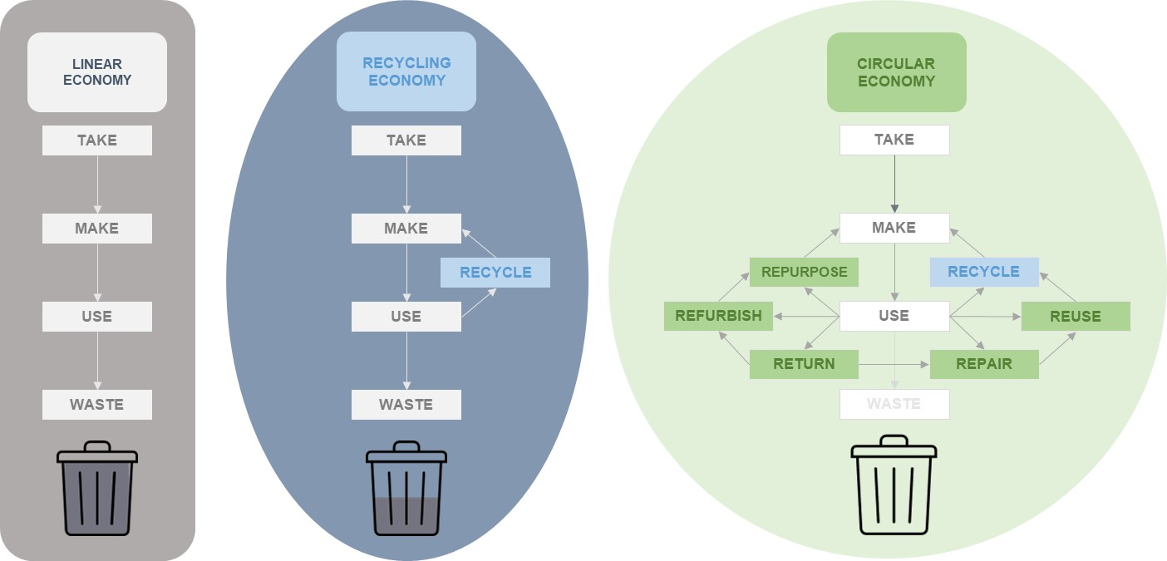

Figure 3 Transition from Linear to Circular Economy

According to the Ellen MacArthur Foundation[2], a circular economy is based on three key principles, all driven by design.

1. **Eliminate waste and pollution:** The first principle of the circular economy is to eliminate waste and pollution. In the linear economy, raw materials are extracted or taken from Earth and products are made out of them. Eventually, these products and materials are thrown away as waste.
2. **Circulate products and materials at their highest value:** Circulating products and materials at their highest value means keeping materials in use, either as a product or, when they can no longer be used, as components or raw materials. This way, resources are kept in circulation, nothing becomes waste, and the intrinsic value of products and materials is retained.
3. **Regenerate nature:** By moving from a take-make-use-waste linear economy to a circular economy, natural processes are supported, and nature can thrive.

To implement these principles and become circular, companies are employing different strategies to transform their current linear way of operating.

Key strategies of the circular economy are set out in the following table:

|  |  |
| --- | --- |
| **Strategies** | **Explanation** |
| Design for Longevity | Products are designed with durability, repairability, adaptability, reusability, and recirculation of inputs in mind, extending their lifespan and reducing the need for constant replacement against fast use. As a result, fewer products are used along supply chains and environmental impacts are minimised. |
| Reuse | Returned products or components are refurbished, repaired, remanufactured, or treated to be "as good as new" or “like-new”, minimising waste and conserving resources. It should be noted that the terms refurbished and remanufactured require different capabilities and mean different things to different sectors. |
| Remanufacturing | During the remanufacturing process, a product is disassembled to its individual components and then reconstructed, replacing any necessary components, to achieve a condition that is equal to that of a brand-new product. The reconstructed product is accompanied by the same warranty as a newly manufactured item. Remanufacturing involves the restoration of used products or components to their original specifications or improved conditions, enabling them to be reused and extended in terms of lifespan. The objective of remanufacturing is to ensure that the final product achieves or surpasses the identical quality standards of a completely new item. |
| Recycling and Recovery | Materials from products at the end of their life cycle are recovered and reused or recycled into products or materials, reducing the demand for virgin resources. |
| Resource Sharing | Collaborative consumption models enable multiple users to use the same resource over time, such as sharing services, renting, or leasing of products. |
| Resource efficiency | Resource efficiency means minimising resource use and the use of virgin material at the source through more efficient and thoughtful product design and manufacturing processes, and optimising resource reuse and recycling. Through improved production processes, resources can be used more efficiently. For example, improving the design of packaging to be as minimal as possible and/or with the option to be reused, results in improved resource efficiency. |
| Biomimicry and Renewable Energy | By emulating natural systems and using renewable energy sources, processes can be powered or improved, reducing their environmental impact. |
| Digitalisation | Digital technologies can be used to optimise processes, track materials, and create new business models that support circular practices. |
| Innovation | Adopting new ideas, approaches, and technologies to redesign products and processes can drive circular economy and enable new business models. Innovative technologies and methods are key to improve all “r-strategies” – repair, reuse, remanufacturing, refurbishment, recycling. |
| Systemic change | A systemic change includes both structural and behavioural transformations for shifting from a linear to a circular business model. It requires collaboration among businesses, governments, consumers, and other stakeholders to reshape production, consumption, and waste management practices. |

By applying the above-mentioned circular economy strategies, businesses have the potential to not only reduce “waste” and social and environmental harm but also to foster innovation and create new business opportunities, access new markets, and spur job creation and economic growth.

# Barriers to circular economy

Across sectors, businesses seeking to put in place circular economy approaches face policy and regulatory, technology, infrastructure, financial, organisational, and social barriers. The main barriers are set out in the following table:

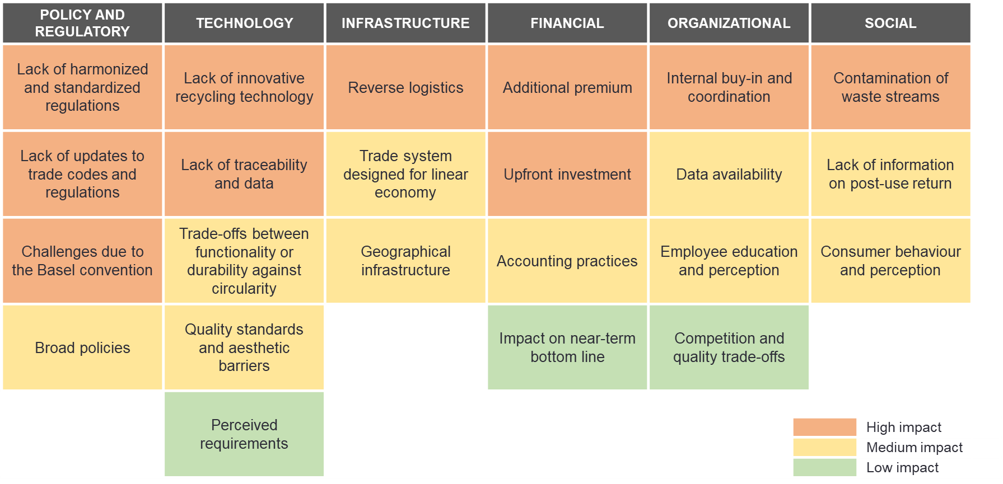

Figure 4: Overview of barriers in circular economy (Industries surveyed included advance manufacturing, renewables, information technology, chemicals and life sciences, textiles. Big material streams such as construction sector or Agriculture, Forestry and Other Land Use **(**AFOLU) are excluded.

## Policy and regulatory

**Lack of harmonised and standardised regulations:** Governments across the world have enacted different environmental regulations making it difficult for both governments and companies to differentiate resources that can be reused, recovered, repaired, repurposed, or refurbished and those that need to be recycled or otherwise disposed of. Illustrative examples include:

* “remanufactured” being defined differently from one country to the next such that an import restriction applies in one but not the other
* some countries categorising a product at the end of its first “life” as “waste” and assigning ownership to the relevant municipality, limiting companies’ ability to extend the lifecycles of products
* Extended Producer Responsibility (EPR) schemes, which while supported by many companies, in many cases are designed differently from jurisdiction to jurisdiction.

This fragmented regulatory landscape is difficult for companies to navigate and drives up compliance and operational costs. As a result, companies struggle to manage their resources efficiently and face logistical and sourcing challenges and impediments when moving circular goods across borders.

**Lack of end-of-life standards:** There are no global standards for product lifetimes or alignment on when a product should be returned to a manufacturer. This makes it difficult for manufacturers to appear impartial when declaring a product to be at “end-of-life”. Companies spend significant time reviewing the applicability of differing domestic standards to circularity. Without an industry standard, the manufacturer is left to self-determine a product’s lifetime and risk the timeframe being perceived as planned obsolescence. The lack of standards and alignment defining when a product reaches “end-of-life” also makes it challenging to determine if a product is ready for a take-back program. But defining a global industry standard is extremely difficult because product life spans differ dramatically depending on the nature of the product and materials uses. For example, a newspaper is typically read and discarded relatively quickly after publication, and it is made out of material intended to reasonably meet this timeframe. However, a product such as a mobile phone may be designed and built with intentional durability and performance ability for several years before reaching its “end-of-life” and returned to the manufacturer.

Placeholder for example of remanufactured good(s) and customs issues

**Lack of updates to Customs classification codes and regulations:**  Customs regulations have been drafted for a linear economy and have not yet been updated to accommodate reverse logistics, which are key to a circular economy. Under current Customs regulations, materials that have completed their initial purpose and are ready for remanufacturing, refurbishment, or recycling, can only be classified as “waste” under the current version of the Harmonized System (HS) for the classification of goods and are thus often subject to bans or restrictions on import/export. This has a direct adverse and restrictive impact on many circular economy goods ranging from used clothing to components for conversion to recycle centres. Moreover, the current HS codes are not granular enough to assess the lifecycle of products such as reused products or feedstock. This means that when goods such as a used pair of shoes are being shipped to be resold directly or processed into new feedstock, tariffs will be assessed using the same tariffication as for a new product since that is the closest item in the HS code available despite the company not being able to charge the price of a new product. Thus, companies may incur losses when selling used products due to being obliged to pay higher duties, which hinders their participation in the resell economy.

In addition, the absence of formalised guidance and instructions regarding the origin and valuation of post-use materials exposes companies to compliance risks and subjective assessments by Customs authorities, often resulting in increased costs. Indeed, customs valuations do not adequately reflect that “waste” products often have no value or that the customer pays the company to take this “waste”. The lack of guidelines on the customs value to be declared for reusable goods results in misaligned tariffs for the actual value of the materials. In other words, a business may be spending more to enact circularity than it gains from participating.

**High costs for compliance:** As country-specific circular policies like plastic bans or EPRs emerge, companies face increasing compliance costs to meet various and differing regulatory requirements and implementation deadlines. This lack of standardisation across jurisdictions also creates supply chain risks when companies rely on small- and medium-sized suppliers overseas who may not have the resources to adhere to EPR schemes, such as the European Union’s.

Placeholder **Example of wind turbine blades** (to include footnote:<https://www.bloomberg.com/news/features/2020-02-05/wind-turbine-blades-can-t-be-recycled-so-they-re-piling-up-in-landfills>)

Decommissioned wind turbine blades are normally landfilled because they are difficult or almost impossible to recycle. Through advances in innovation, companies are now able to recycle the blades and use them for other purposes. This however creates Customs issues, which stand in the way of recycling:

* **What is the tariff code for a decommissioned wind turbine blade?** There is no tariff code for disused wind turbine blades. Lacking this, the company must use tariff codes for glass fiber waste or for new wind turbine blade. Given that there may be different tariff rates for the different tariff codes, it increases the costs for the company.
* **What is the customs value of decommissioned wind turbine blades?** How they are valued for Customs purposes can significantly impact how much import duty a company must pay. Customs authorities often do not take into account that the product often has no value or in some cases that the customer pays a company to take the “waste”. It is also unclear how to deal with negative Customs values.
* **What is the origin of the decommissioned wind turbine blades?** They may originally have been manufactured in Morocco, installed in the United Kingdom and then after 30 years imported to Denmark for recycling. Is the origin of the product Morocco or the United Kingdom? Again, this makes a difference as there might be very different customs rates depending on origin.

The lack of clarity on these questions means increased compliance costs for companies and may expose the importers and exporters of record to potential fees and penalties. The lack of certainty and predictability may also discourage investment, slowing the growth of the circular economy.Top of Form

**Challenges due to the Basel Convention:** The Basel Convention, established in 1989 as the pivotal international treaty governing the control of transboundary movements and disposal of hazardous wastes, aims to limit the cross-border movement of hazardous waste. It was specifically designed to prevent the transfer of hazardous waste from developed to less developed countries. However, while well-intentioned, it has created barriers to the development of reverse logistics programmes, impeding goods from moving back to sellers and manufacturers, which is crucial to a circular economy. Key barriers include:

* **Absence of distinction between ‘recyclable’ and ‘non-recyclable’:** The failure to differentiate between ‘recyclable’ and ‘non-recyclable’ waste under the Basel Convention has resulted in unnecessary restrictions on the transboundary movement of products and materials. As a result, companies have less access to secondary raw materials, which are necessary for circular economy systems to function. There is an ensuing debate among policymakers regarding whether the special characteristics of recyclable “waste” could justify the adoption of less stringent rules to facilitate their movement or if this would encourage fake recycling schemes.
* **Absence of classifying hazardous and non-hazardous waste characteristics:** The Basel Convention's system of classifying hazardous wastes and hazardous characteristics is overly broad, covering a disproportionate range of substances. One of the key problems with the efficient implementation of the Convention concerns the use of Annex III, which lists hazardous characteristics. Also, there is a lack of criteria to define some characteristics, especially for the last four classes in the list (H10–H13). For similar reasons, there are difficulties with the application of some of the categories of wastes listed in Annex I (e.g. Y18: ‘residues arising from industrial waste disposal operations’).
* **Failure by the United States to ratify the Basel Convention.** Whilst a signatory, the United States has not ratified the convention because it does not have sufficient domestic statutory authority to implement all its provisions. This poses an additional challenge to the transboundary movement of waste since American companies do not always have easy access to secondary raw materials in the international market.

**Broad policies:** A lack of technical knowledge among policymakers has created hurdles in crafting more granular and enabling legislations. Current regulations are often overly broad, thus making them difficult to implement and limiting the potential of some circular solutions. For example, in the IT sector, the design and end-of-life recovery of low-volume, high-value products differ considerably from those of mass-market, low-value consumer products, but regulations do not take these differences into account. Broad policymaking may also force companies to choose between durability and sustainability. For example, there are many different types and sources of plastic, but goods using circular plastic that are extremely durable, even almost indestructible, are treated the same way as goods made of lower quality and less durable plastic.

## Technological

**Lack of innovative recycling technology capacity:** Existing recycling facilities only treat a handful of materials. Significant investments are required to develop and increase their recycling capacity, but the lack of legal certainty and the regulatory complexity regarding the future use of recycled materials are limiting investments in recycling technologies. Currently, there is also insufficient demand for most recycled materials. For traditionally hard-to-recycle materials and materials with limited economic value, innovations are at different stages with varying potential for scaling up. Thus, many companies have limited options to use recycled materials without completely revising their product offerings. Further, recycling facilities for certain materials are highly specialised and are not available in all countries, particularly smaller ones, requiring the “waste” to move across borders which as noted above, is hampered by current regulations.

**Lack of traceability and data:** The absence of traceability and data on certain product ingredients impedes many circular economy strategies, in particular recycling and refurbishing. The inability to fully determine the chemical and material composition of products results in them being incinerated rather than reused. Commercial design specifications and required standards for materials can pose challenges to companies who strive to balance desired output of the product and circular design, such as design-for-repair, design-for-disassembly, and the ability to adopt alternative or recycled materials. Moreover, data collection is also challenging, especially for “end-of-life” collection and processing, as the materials are scattered and segmented across markets. Because of insufficient data quality, companies have difficulty accurately monitoring performance and forecasting demand for outputs incorporating circular design.

**Trade-offs between functionality or durability against circularity:** Some circular materials are economically viable to be produced at scale, but they may be at a competitive disadvantage compared to virgin materials in terms of their technical and aesthetic properties. Design-for-circularity sometimes can also entail trade-offs between functionality or durability against circularity. For example, it is a challenge to develop a shoe that can be easily disassembled, and its components recycled without negatively affecting its durability. Conversely, when a product is designed for durability by for example using an extremely strong material, it is difficult to disassemble it to reuse or recycle components.

**Quality standards and aesthetic barriers:** Technical and aesthetic barriers arise due to exacting quality standards for products. Engineering departments conduct quality assurance checks to ensure that products meet certain specifications and quality standards. Check processes involve risk assessments to determine how and where a product is most likely to fail and determine which material characteristics are suitable for an application. Technical and aesthetic issues arise when assessing whether recycled material can directly replace a virgin material for a product. In many cases, the strength of a virgin material is greater than that of the same recycled material. Aesthetic characteristics such as colour, appearance or texture can be difficult to replicate when using recycled material.

**Perceived requirements:** The perception of technical barriers creates a tension between what is actually necessary and what is presumed to be a necessary specification for recycled materials. Companies have many internal discussions about technical specifications, which can make it difficult to discern whether a product specification metric was required for performance reasons, a customer requirement, or an industry standard. Consequently, there is a risk of applying perceived specifications to recycled materials that are in fact not necessary for product performance.

## Infrastructure

**Reverse logistics:** Capacity constraints exist throughout the reverse supply chain from take-back collection points to sorting, disassembly and remanufacturing and recycling facilities. These constraints limit the supply of recycled materials. Registering the product, tracking the product, and enabling customers from other countries to send back a product are all barriers to post-consumer collection. In some instances, products cannot be returned in a country where the manufacturer does not have a factory or other established presence because of import/export regulations.

**Lack of collection infrastructure:** Currently there is no established infrastructure for collecting, recovering, and processing of “end-of-life” materials. Establishing such infrastructure is costly, and there are unclear responsibilities between the private sector and the government. On a macro level, there is a geographic disconnect between where collection, reprocessing, and advanced recycling technologies are located and where “waste” is located. These challenges limit the volume of post-use materials available for processing, consequently constraining scalability. Furthermore, the failure by consumers to return or sort products affects the quality of post-use material streams, hindering the profitability of potential circular solutions.

**Lack of availability of raw materials**: There is often not enough recycled material of sufficient quality and low contamination in the market to meet demand. The small number of recycled material suppliers compared to the number of suppliers available for virgin materials further increases supply chain risks and vulnerabilities. It makes it difficult to set recycled content targets if a reliable supply cannot be secured.

**Limited scalability:** Some circular practices might work well on a small scale but struggle to be scaled up to meet the demands of larger markets. As successful circular initiatives expand, companies encounter unique challenges during the scaling up process. These may include maintaining product quality, ensuring consistent material supply, and accommodating increased demand. Many circular processes must be at a large scale to be able to have the correct output quality and be economically feasible.

## Financial

**Additional premium:** Circular materials often carry a premium due to the high cost of reprocessing and limited supply while operating in a primarily linear model. In some cases, the cost of processing used products for resale surpasses the cost of manufacturing all-new products. For some specific materials that are used in multiple sectors such as recycled PET, competition over the materials further drives up their price and jeopardises established circular material flows. The additional costs associated with circular materials disincentivise many companies from switching from linear models to circular alternatives.

**Upfront investment:** Research and development (R&D) and upscaling of circular practices require substantial up-front investments, posing financial risks. This investment hurdle limits circular innovation to large corporations committed to circular principles, and the cost burden is borne by brand owners or consumers. The risk of investing in circularity is perceived as high relative to other investment opportunities, limiting the availability of capital for circular economy investments.

**Accounting practices:** Accounting practices can be significant hurdles for the circular economy. Currently, financial practices and accounting are unable to accurately value the financial benefits of circular economy projects. For instance, consider a renewable energy company that invests in recycling and refurbishing its solar panels to extend their lifespan. While this circular approach benefits the environment, it may not be adequately reflected in generally accepted financial statements. The challenge lies in quantifying the long-term environmental and societal gains in a way that aligns with conventional financial reporting. This discrepancy makes it difficult for companies to demonstrate the full economic value of their circular efforts. This underscores the need for innovative accounting methodologies and reporting frameworks that can better capture and communicate the holistic benefits of circular economy initiatives.

**Impact on near-term bottom line:** One significant barrier is the immediate impact on a company’s bottom line during the transition to circularity. For instance, a wide range of retail products and textiles are petroleum-derived, anchoring the cost of virgin materials to oil prices. With comparatively low oil prices and without policy levers to create incentives for alternative material choices or the reuse of existing petroleum-based products, maintaining linear systems of production remains the better financial decision for companies. While circular products face profitability challenges due to their higher production costs, they often generate longer-term returns on investment (ROI) compared to products produced under traditional linear practices that focus on quarterly or annual performance metrics.

## Organisational

**Internal buy-in and coordination:** The shift to circular business models requires collaboration across multiple functions within an organisation. A lack of internal buy-in and coordination may slow this transition. Internal processes may need to be updated to accommodate a circular system, which require liaisons to shepherd concepts for circular products from ideation to market. Securing internal buy-in can be a challenge if the financial impact to change existing, successful business models is significant or if the transition introduces significant supply chain risks and costs. Convincing clients and internal stakeholders about the benefits of circular economy practices remains an ongoing challenge. Additional challenges include:

* **Dependency on new partners:** Most companies using recovered materials seek external partners with complimentary capabilities to implement the changes required to become more circular. Putting trust in a new partner in a strategic programme is seen as risky, and it can be sometimes challenging to acquire the right partnerships for a variety of reasons. However, fruitful collaborations are possible, generating mutual growth within these new-found partnerships.
* **Supply chain challenges:** Supply chain management needs significant adjustments to accommodate circular materials and products, which could be challenging when strict KPIs and targets are in place. For example, the number of circular material suppliers that meet the quantity and quality requirements may be much fewer than that of traditional material suppliers, which translates into higher supply chain risks. In addition, due to the limitation in supply, lead time and cost of transportation might increase, which also goes against conventional good practices.
* **Measuring progress:** Current frameworks for circular progress measurement are not closely connected to other ESG frameworks such as the Greenhouse Gas Protocol, limiting companies’ ability to accurately measure their circular performance. For instance, substituting a virgin material for a recycled material may boost some circularity indicators but can have a negative impact on a company's greenhouse gas footprint, compromising their nature and climate objectives. Adopting a holistic and scaled up circular economy approach may reduce such trade-offs.

**Data availability:**In the traditional linear model, companies transfer ownership of materials to their buyers, limiting their ability to track materials for reverse logistics. As post-sale products scatter, the decentralised, fragmented recovery system ceases to provide sufficient data for upstream designers and producers to efficiently plan for circular supplies. Value-chain wide efforts are needed to improve data availability and quality, enabling better integration of circular materials into current supply chain management practices.

**Employee education and perception barriers:** A lack of understanding of circular economy concepts is a barrier to progressing initiatives within companies. There is a general misconception that circularity is the same as recycling. This misunderstanding leads employees to believe that recycling alone is sufficient to create a circular economy, limiting the success of internal initiatives to reuse or refurbish products. Employees stuck in this type of thinking make the transition to circular concepts challenging.

**Competition and quality trade-offs:** Transitioning to new technologies, especially in the IT sector, presents challenges as companies rush to keep up with competitors and meet the demands of fast-paced innovation cycles. The urgency for innovation and for products to reach the market can be at odds with the time needed for products to be designed with circularity in mind. In the race to market, companies may overlook opportunities to create more sustainable and circular products. The fiercely competitive nature of the IT industry and the pressure to release new products quickly can clash with the long-term sustainability goals of circular product development. This challenge is further exacerbated by the need to align technical standards, design demands, and revenue goals with circular principles, creating a complex interplay of factors.

## Social

**Lack of information on post-use return:** Recovering post-use materials for resale, refurbishment, remanufacturing, or recycling starts with design but involves active participation from end-users. Currently, consumers lack information on reverse logistics and take-back processes -- simple, informative, and practical instructions on labels are lacking. Consequently, they may be unaware of take-back programs or collection points for drop-offs. This lack of awareness lowers consumer convenience, resulting in lower volumes of post-consumer feedstock available for effective upcycling into new products. While labelling can be an effective tool, it introduces traceability challenges – labels are removed by consumers, making them an ineffective tool for subsequent product lives.

**Contamination of materials streams:** In relation to municipal materials management systems and brand-driven take-back schemes, there is often contaminations in the “waste” stream. This is because end-users do not follow return instructions. For example, instead of returning one component, they send the entire product back. This leads to contaminated material streams that exacerbate the complexity and costliness of the recovery processes. Also, improper disposal of end-of-life materials leads to contamination that inhibits reprocessing efforts. Contaminations in materials streams make it technically more challenging and labour intensive to effectively recover value in post-use materials. This further increases the cost of establishing circular loops. Companies running take-back programmes often find misplaced items in the return stream, requiring extensive manual sorting and posing compliance challenges, notably in subsectors such as children’s toys. Apart from the contamination of the materials stream due to the inclusion of incorrect materials, there are sanitary concerns related to recycled base materials that are often worn or used and thus not sterile. Existing systems often require these materials to be washed and sterilised in advance of handling, further complicating the process.

**Consumer behaviour and perception:**Consumer behaviour is currently aligned to a linear economy, which presents three main challengesto implementing a circular economy:

* **Perception of value:** Misperceptions about the quality of remanufactured, refurbished, or recycled goods and materials negatively impact the demand for circular offerings. Consumers currently prioritise convenience and prefer new products over recycled and refurbished ones due to a lack of education and awareness about the benefits of refurbished devices. Complex recycling and return/take-back processes further contribute to this consumer preference.
* **Novelty or sentiment for an item:** Consumers often attach symbolism and sentiments to purchases and may be reluctant to forego ownership in the transition to circular business models. Consumers often assess a used product’s value according to how they feel about it instead of its actual market value. Moreover, cultural, or social stigma associated with second-hand or refurbished products in some regions or communities can discourage individuals from embracing circular options, despite their economic and environmental viability.
* **Prioritising cheaper disposable options:** Consumers typically favour low prices and convenience over sustainable options. Products designed for disposability tend to be cheaper and more readily available, making them more appealing to many consumers. This can deter the adoption of circular products or services which but may be more expensive or require extra effort to access or maintain.

# Measures to support the transition to a circular economy

As discussed in Section 4, regulatory, technology, infrastructure, financial, organisational, and social barriers are hindering widespread adoption of circular economy business models. However, opportunities exist to alleviate the pressures of these barriers across sectors that can play a vital role in paving the path for a circular economy and a sustainable future.

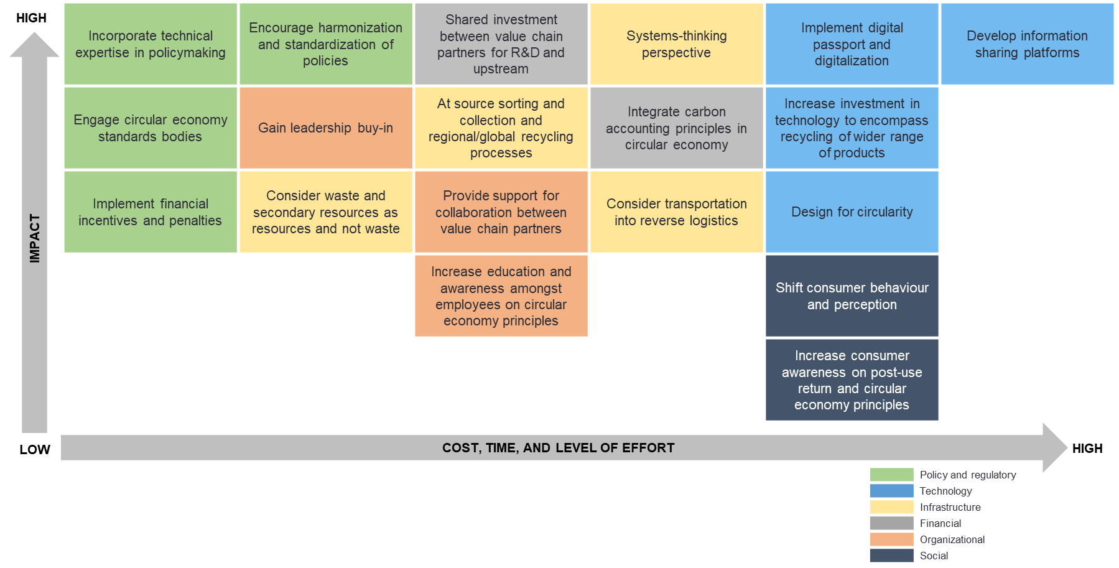

Figure 5: Recommendations and next steps for circular economy

## Policy and regulatory opportunities

**Harmonisation and standardisation of policies:** There is an urgent need for globally harmonised standard and policies to pave the way for consistent progress in the circular economy. For example, harmonising Extended Producer Responsibility schemes across jurisdictions would simplify compliance and cut costs for companies. Sensible, aligned, and harmonised policies across borders are necessary to ensure that all entities worldwide follow the same guidelines for smooth trade and compliance. Most sectors consulted for purposes of this report are subject to complex technical and legacy policies and laws intended to drive innovation. Thus, new circular economy focused policies need to co-exist and harmoniously work with the existing nuanced policy landscape. The combination of globally standardised policies and local initiatives, achieved through stakeholder consultation, holds the key to advancing the circular economy on a global scale.

**Incorporate technical expertise in policymaking:** Incorporating additional technical expertise in policymaking would lead to more targeted regulations. For example, given the lack of definitions of ‘recyclable’ and ‘non-recyclable’ and ‘hazardous’ and ‘non-hazardous’ “waste”, integrating technical expertise into policymaking would help establish precise, transparent, and concrete definitions. This, in turn, would pave the way for efficient circular systems. Also, technical expertise could help provide a more granular and hierarchical approach to define “waste” as refurbished, remanufactured, reused, and recycled.

**Engage circular economy standards bodies:** The lack of globally accepted definitions for even the most basic circular economy terms, including remanufactured, refurbished, like-new, repurposed, and used, creates regulatory uncertainty for businesses considering investments in circular economy. These terms need to be defined by a whole of government and multilateral approach, so that objective criteria can be globally adopted to enable the identification and streamlined movement of physical goods needed for the circular economy across borders. The failure to define these critical terms leaves their use open to interpretation and possible misapplication and/or misinterpretation by both governments and businesses. More broadly, updates to existing regulations and frameworks must be done on an on-going basis to keep pace with continuously emerging innovations, such as advancements in waste recovery technologies. Standards must evolve alongside these technologies and include business in their development.

**Domestic inter-agency cooperation and whole of government approach:** Domestic-level discussions involving all government agencies are necessary to tackle issues like restrictions and prohibitions on imports at all life-cycle stages and levels. Clear processes need be established to facilitate and enable a circular economy for all stakeholders in one country and to enable a move towards more harmonisation across countries.

**Penalties and incentives**. Long-term solutions may include limitations on specific materials and linear disposal practices. By restricting certain materials and disposal methods, policies can propel industries towards circularity by creating demand in the market. A crucial aspect lies in striking a balance between regulatory measures like restrictions, bans, and taxes, and proactive support measures and incentives. Government-backed initiatives and dedicated circular funds stand as catalysts for increased investment in circular innovation, fostering a conducive environment for industry transformation. Any consideration of subsidies must be done in full compliance with the WTO Agreement on Subsidies and Countervailing Measures (SCM) to limit market distortions that may limit the trading of circular goods. Current policies lean heavily towards restrictions and a prescriptive approach, whereas the magnitude of changes and investments required call for supportive and enabling measures. A comprehensive policy framework, integrating penalties, incentives, and support measures, is pivotal in steering industries towards circularity.

## Technological opportunities

**Investment in technologies to encompass recycling of wider range of products:** Globally, both mechanical and chemical recycling technologies are not mature enough to be cost-effective and economically viable. While these technologies show significant potential, their further development and scalability require continued policy-driven and financial push from regional and national governments. An enabling environment could help drive the significant investments needed to scale capacity and accelerate technological innovation. For example, mandating a percentage of recycled materials in certain products could potentially generate the momentum needed to encourage chemical companies to scale up their technology and production capabilities.

**Design for circularity:** Technological advancements may help create circular materials or designs at lower cost and with improved qualities, thus eliminating the barrier for designers and brand-owners to make the shift. Contamination and inadequacy of “waste” management infrastructure pose significant challenges in purifying feedstock required for recycling or recovery processes. To address structural challenges, two primary avenues can be pursued: ensuring recycled materials feedstock maintains minimal levels of contaminates and advancing industrial processes beyond current methods. For recycled materials to seamlessly replace virgin material, standards and metrics must evolve and be scrutinised. Establishing ranges of toleranceis pivotal in assessingthe suitability of recycled materials for particular applications.

## Infrastructure opportunities

**Systems-thinking perspective:** Resource efficiency and circular economy policies need to implement a systems-thinking approach across society in general. Systems thinking involves understanding how various systems influence one another within a larger system. This enabling tool can help identify root causes and help frame the conceptual understanding of a new circular business model, including infrastructure transitions.

**At source sorting, collection and regional/global recycling processes:** Mandatory “waste” sorting and collection at the source is crucial, coupled with instituting policies that enable the development of necessary infrastructure to support operation or process changes. Existing regulations hinder “waste” transportation and trade because they do not value “waste”. Thus, “waste” needs to be reframed as a by-product. For instance, to address the pervasive challenge of exporting post-consumer textiles, local policymakers can help to regionalise a circular economy for textiles by creating incentives for local collection, regional sorting, reuse, or recycling.

**Rethinking “waste” and secondary resources**: To shift the perspective on waste and secondary resources, it is vital that “waste” is reframed as a resource. Narrowing the scope of what is considered waste will encourage more circular business models. On a practical level, secondary resources can be further optimised in a number of ways and by applying different strategies:

* Incorporating detoxification (i.e., the removal of harmful contaminates) into design lengthens products’ lifecycle by considering the impacts of chemical compounds.
* Industrially processed material residues, like pomace, should be collected for further processing rather than being treated as “waste”.
* Incentives and benefits should be offered to companies offering product innovations which turn “waste” materials as raw resource into new products.
* Investing in recycling infrastructure and collection systems tailored to new material types like bio composites and bio-based foams should be encouraged.
* Sorting and recycling facilities need to evolve with circular material innovations. This should start with setting definitions, e.g., for textile waste, and harmonising “end-of-life” criteria at regional and national levels to secure the constant flow of high quality secondary raw materials.
* There also needs to be consideration for the significant amount of “waste” that needs to be transported in the piloting and development phase of innovative circular solutions.[3]

**Strategic material banks**: Strategic material banks, acting as safe reserves for recoverable materials which are currently lost in landfills, could address the scarcity of certain materials. When coupled with effective detoxification processes, they could pave the way for a constant supply of strategic materials, ensuring their availability for future use.

**Prior Informed Consent (PIC) procedures:** The Basel Convention sets forth PIC procedures, documentation, financial assurance, and trade bans on certain shipments of hazardous and other wastes with the aim of ensuring the environmentally sound handling of waste traded internationally for recycling and recovery. However, for the Convention to achieve its objectives, it is paramount that the PIC procedures function consistently and efficiently, especially concerning “waste” destined for materials recovery or recycling. In practice, many countries lack the resources or capacity to fully operationalise the PIC procedures, and communication and logistical challenges have been well documented. As a result, businesses face significant shipping delays and operational uncertainties, undermining the objective of environmentally sound management and broader circularity goals. Modernising the PIC procedures through digitalisation and other trade facilitation measures will contribute to safe and efficient circular material flows.

**Information sharing platforms:** To increase awareness of circular economy strategies, companies across value chains can serve as information sharing hubs to educate large numbers of vendors on compliance requirements. Moreover, interconnected, cohesive performance measurement systems are essential. These systems prevent the penalisation of circular economy solutions and enable companies to better set targets and measure progress towards these goals.

## Financial opportunities

**Financial incentives:** There is a pressing need for financial instruments to drive industry to shift from a linear to a circular model. Firstly, incentivising innovation and creating market demand for circular products can motivate businesses to invest in circular economy practices. Addressing financial risks and offering incentives can aid in scaling up circular initiatives. Introducing tax incentives can spur innovation in bio-based and circular materials. These financial incentives should help offset research and development (R&D) costs and scaling of sustainable materials. Also, funding, testing and piloting of circular materials can accelerate their adoption and facilitate de-risking and validation, bringing them to the market faster and making it as easy and profitable for businesses to internalise external costs and to embrace circularity as to have a linear business model.

**Carbon accounting:** The move towards carbon accounting can be an essential component for accurate evaluation and measurement of circular practices. These emerging trends have the potential to provide companies with the tools and methodologies needed to assess and report the environmental impact of their circular practices, surpassing traditional financial metrics. Integrating circularity metrics into accounting practices allows organisations to have a more comprehensive understanding of the sustainability and efficiency gains achieved through circular initiatives. With increasing costs for carbon emissions, circular economy approaches are becoming more attractive as they have lower carbon emissions than virgin material extraction. Ultimately, this may drive the adoption of circular economy principles across various industries.

**Shared investment between value chain partners for R&D and upscaling:** Investment in research and development of circular solutions, spanning from prototype design-for-disassembly to advanced recycling, is costly. Generally borne by the innovator, the cost may be shared among value chain partners. The premium due to technology costs are especially pronounced when production volumes remain low. To alleviate this, specialised funding for circular initiatives could support capital inflows, encouraging investments towards R&D activities. Introducing policies such as EPR across the value chain can make consumer-facing companies accountable for plastic residuals, products and packaging, such that the transformation cost will be borne equitably.

|  |
| --- |
| **Financial institutions can facilitate the transition towards a circular economy in several ways[4]**:   * The bankability of circular business models in many cases requires the acceptance of ‘contractual comfort’ instead of the right of legal ownership over assets in case things go wrong. Secondly, it requires a more cash flow-based approach to finance rather than an approach based on collateral values. * Banks can enable the circular economy by developing valuation and risk models that suit the characteristics of circular business models. For example, assets are often written down to zero or a small scrap value over their economic life cycle. Capturing higher values in circular supply chains through upscaling or through second hand markets is pivotal to the circular economy, but currently this value is not fully captured in financial business cases. * Exploration and development of leasing arrangements for products with circular potential. * Exploration and development of new and innovative finance solutions for supply chains that go beyond the currently available working capital solutions. * Advising clients on the financial incentives that make the end user choose for circular products and services over standard products. Currently many business models are financially sound for the client, but they lack a strong financial incentive for the end user. If the financial benefits are not clear to the end user, circular business models are bound to face limited demand. * Development of knowledge on and gaining experience with new pricing tools that incorporate environmental and social costs and benefits into the financial business case. * Partnering with equity providers if the risk return profile of the circular business case does not match debt finance criteria |

## Social and organisational opportunities

**Leadership buy-in:** The transition to circular products requires strong commitment and support from leadership, particularly as circular initiatives are usually not profitable in the short term, making them vulnerable to shifting company priorities. Leadership buy-in can enable companies to adopt a holistic approach to circular economy across the whole company. It can also have a positive impact on internal sustainability and circularity efforts if the value of circular economy is recognised across the company since it will empower employees and teams to innovate.

**Effective consumer awareness and engagement:** Consumers of all ages, including children, must be educated about circular economy concepts that extend beyond recycling. The aim is to shift perceptions towards maximising the use of existing resources, emphasising the benefits, and dispelling misconceptions. As consumer awareness and demand for eco-friendly and local products and services grow, businesses are encouraged to prioritise circular practices. Policies aimed at consumer education are crucial in stimulating demand for circular products. Promoting awareness through campaigns and offering financial incentives, such as rebates on future purchases for returning products, may help overcome convenience-based obstacles, thus increasing consumer interest and participation in circular practices.

**Labelling policies:** Labelling policies are a particularly effective means to provide customers with information to facilitate their understanding of products’ circularity, encouraging prolonged used and contributing to a more circular economy. However, it is critical to consider a circular product’s anticipated multiple uses before it reaches the final stage of recycling.

**Consumer behaviour and perception:** Academic research on consumer behaviour within a circular economy is still in the early stages. Research studies could help to explain challenges like low recycling rates or the factors influencing a customer’s decision not to return an item. Overall, there needs to be a better understanding of how consumer behaviour can be efficiently aligned to a circular economy, since it is critical to creating a circular system. When developing new reverse logistic channels such as collection points, consumers must be provided with consistent, easy to access, and easy to use entry points to participate in the circular economy.

# Key recommendations

Placeholder – to be added.

This section will be the conclusion and will be addressed to policymakers focusing on key recommendations as set out in the graph below and previously circulated as slides.

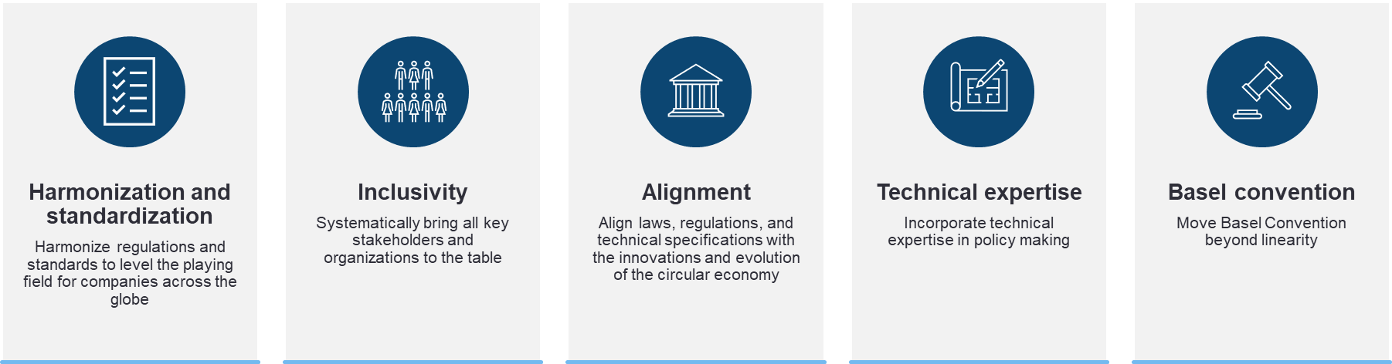

# Annex

## Research methodology

This report aims to comprehensively examine the barriers that hamper the adoption of circular economy solutions and provide specific solutions to help address these barriers. To achieve a thorough understanding of the challenges, the research methodology employed combines literature review, stakeholder interviews, and surveys.

**Literature review:** A literature review on both national and international circular economy initiatives, including government documents, policy reports, and research papers, identified commonly observed barriers that policy instruments seek to address and related government-led interventions. This analysis provides a contextualised backdrop for understanding stakeholder inputs in formulating policy recommendations in this report.

**Stakeholder interviews**: Interviews were conducted with industry stakeholders from the manufacturing, life sciences and chemicals, renewable energy, information technology, technology (IT) or information communication technology (ICT), and textile and retail sectors. Interviewees were selected based on experiences of implementing circular economy initiatives, leveraging ICC’s global network. These interviews were structured with an interview guide, allowing participants to provide in-depth insights into their experiences, obligations and challenges faced, and recommendations for implementing circular initiatives. The qualitative data obtained from interviews offer nuanced perspectives and real-world examples that contribute to a deeper understanding of the subject.

**Survey:** To gather inputs from a broader base of stakeholders, a survey was sent to the ICC Circular Economy Working Group. The survey questionnaire aligns with the interview guide, asking respondents about the challenges encountered enacting circular economy initiatives. This data supplements stakeholder inputs during the interview process, contributing to a more holistic understanding of the challenges.

Qualitative insights from interviews were analysed at the sector level, then synthesised for industry-agnostic themes and patterns. Survey responses were reviewed and integrated into the interview analyses to form the industry perspectives. These insights were cross-referenced with findings from the literature review to identify potential gaps that could be addressed through policy interventions. By employing a mixed-methods approach that combines interviews, literature review, and surveys, this research methodology combines the pain points from practitioners with learnings from existing policy frameworks. The triangulated analyses established a well-rounded evidence base for informed and practical policy recommendations.

## References

1. Circularity Gap Reporting Initiative. 2023. 'Circularity Gap Report 2023.' Accessed 21/12/23. https://www.circularity-gap.world/.
2. Ellen MacArthur Foundation, "What is a Circular Economy?," Ellen MacArthur Foundation, accessed January 4, 2024, <https://ellenmacarthurfoundation.org/topics/circular-economy-introduction/overview>.
3. ICC (2023): Circular material flows for research and innovation. https://iccwbo.org/news-publications/policies-reports/circular-material-flows-for-research-and-innovation/.
4. ING Economics Department, Rethinking finance in a circular economy, May 2015, p 8.